IBM ASSIGNMENT – 2

**TEAM ID: PNT2022TMID17404**

**DATE:13/10/2022**

**College: Mahendra Institute Of Teacnologe.**

ASSIGNMENT QUESTION:

**Build a python code, assume you get temperature and humidity values (generated with random function to a variable) and write a condition to continuously detect alarm in case of high temperature.**

EXECUTION RESULT

Program

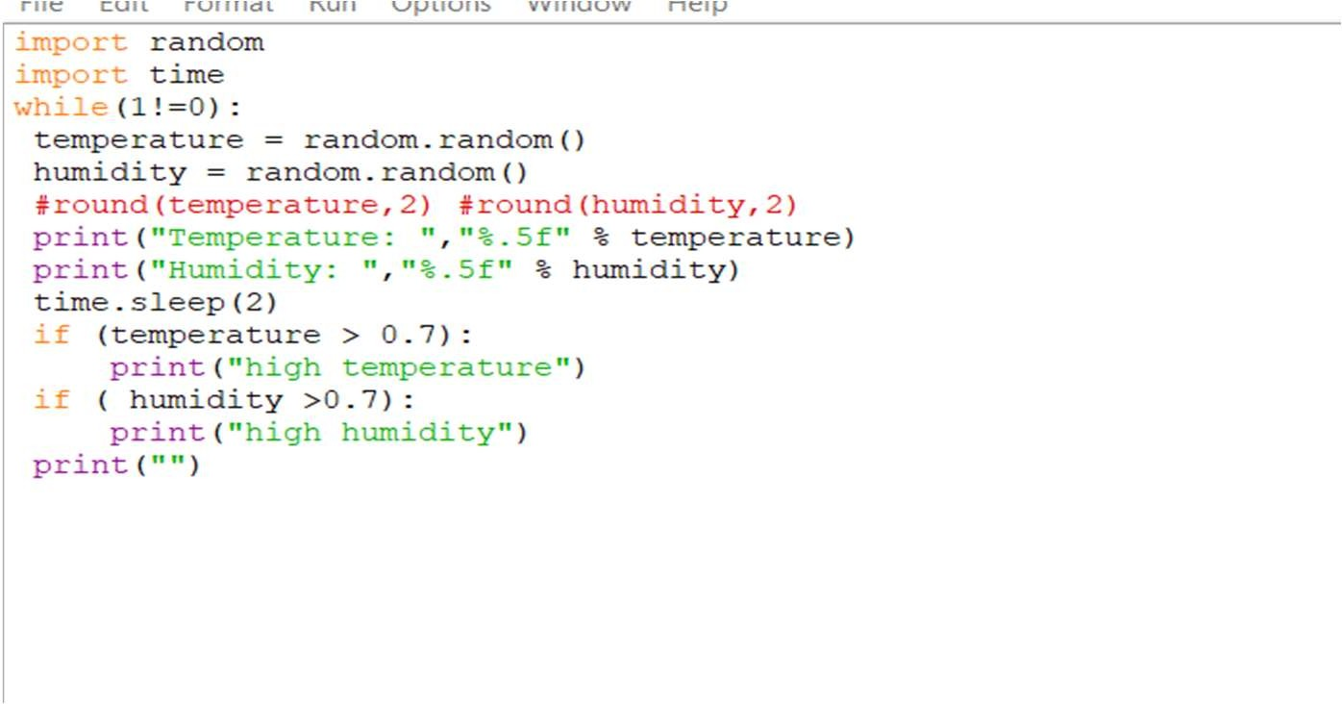

Output

